Product Manual: Adapted Recorder Button

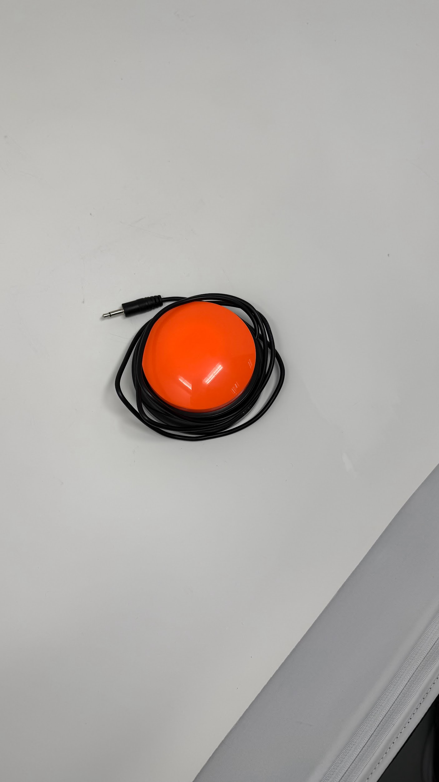



Revision: 1.0

Date: 01-Dec-2025

# Table of Contents

**Table of Contents 1**

**1. Introduction 2**

1.1 About the Community Partner 2

1.2 Product Description 3

WHY? 3

WHO? 3

WHAT? 3

HOW? 3

1.3 Product Overview and Features 4

1.4 Bill of Materials (BOM) 5

**2. User Guide: Instructions for Use 6**

2.1 Set Up Instructions 7

2.2 Maintenance 8

2.3 Troubleshooting 8

**3. Maker Guide: Assembly Instructions 10**

3.1 Assembly Guide 11

**4. Credit and Open Hardware Licence 13**

4.1. Open Hardware Attribution 13

4.2. License Statement and Source Availability 14

4.3 CERN Open Hardware Licence Version 2 – Weakly Reciprocal (CERN-OHL-W 2.0) 15

# 1. Introduction

## 1.1 About the Community Partner

Our journey began in 1970 with the will of Mrs Shakuntala Bhatia. Under the banner of the Asian Women’s Welfare Association, Mrs Bhatia and her peers, like Mrs Tambyah and Mrs Kula, identified gaps in the community to help the underserved.

The Association incorporated AWWA Ltd on 7 January 2015, a Singapore company limited by guarantee. In April of the same year, AWWA Ltd took over the operations and activities previously managed by the Association. In 2022, the Association was dissolved, and AWWA continues to address social service gaps as they arise, by being guided by our mission and strategic vision.

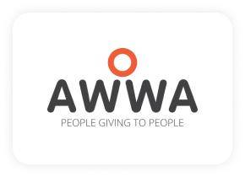

## 1.2 Product Description

This table clarifies the intended purpose and scope of the product:

| **WHY?** | Special needs students are often excluded from using toys or face a lack of appropriate ways to express themselves. |
| --- | --- |
| **WHO?** | For Special needs students who are learning to understand cause-and-effect and have fun. |
| **WHAT?** | Button with audio recording and playback function, adapted with added 3.5mm male mono audio cable to trigger the power on/off of other toys. |
| **HOW?** | This product transforms an off-the-shelf pet button into a durable and responsive device that records, plays back audio, and triggers the power on/off other toys. It allows students to experience and understand the cause-and-effect. |

## 1.3 Product Overview and Features

1. Adapted Recorder Button can playback audio.
2. Adapted Recorder Button can record audio.
3. Adapted Recorder Button can trigger other toys to power on/off via the 3.5mm male mono audio jack cable and both trigger and playback audio.

## 1.4 Bill of Materials (BOM)

| Item | Supplier/Product Link | Price | Quantity |
| --- | --- | --- | --- |
| Pet Button | [Click Here](https://shopee.sg/product/988324402/19687918589?gads_t_sig=VTJGc2RHVmtYMTlxTFVSVVRrdENkY0N5akVpcE5OamJEdjRRTHBOTzhmbVI2Z1hOZjNDaEE1RHNVVmg4V1daY3RPall2RWx1eVdScXkxY3Z4Z1hZeXZjVjZwUGhvd3NTTmRnSWVJV0JlRCt4SVB2REJMRUQxTXJ1YXBKOVZ0WDI&gad_source=1&gad_campaignid=16988858131&gbraid=0AAAAADPpRQSXQtvGUMdikUXOw1R6CaWYe&gclid=CjwKCAiA3L_JBhAlEiwAlcWO57OJzOhjTAh-NC3FWlXA6pY6-TUtMv2VRpqYy8qoJoOv8dt8GmvlahoCTs0QAvD_BwE) Shoppe link - Link too long [Click Here](https://www.lazada.sg/products/pdp-i3278137958-s22045282703.html?c=&channelLpJumpArgs=&clickTrackInfo=query%253Apet%252Bbutton%253Bnid%253A3278137958%253Bsrc%253ALazadaMainSrp%253Brn%253A67e2382e3654fc700c58c27bff2b4bc0%253Bregion%253Asg%253Bsku%253A3278137958_SGAMZ%253Bprice%253A5.5%253Bclient%253Adesktop%253Bsupplier_id%253A1158963101%253Bsession_id%253A%253Bbiz_source%253Ah5_hp%253Bslot%253A0%253Butlog_bucket_id%253A470687%253Basc_category_id%253A10100632%253Bitem_id%253A3278137958%253Bsku_id%253A22045282703%253Bshop_id%253A1484483%253BtemplateInfo%253A-1_A3_C%25231122_L%2523107878_E%2523&freeshipping=1&fs_ab=2&fuse_fs=&lang=en&location=Singapore&price=5.5&priceCompare=skuId%3A22045282703%3Bsource%3Alazada-search-voucher%3Bsn%3A67e2382e3654fc700c58c27bff2b4bc0%3BoriginPrice%3A550%3BdisplayPrice%3A550%3BsinglePromotionId%3A-1%3BsingleToolCode%3A-1%3BvoucherPricePlugin%3A0%3Btimestamp%3A1764822947887&ratingscore=&request_id=67e2382e3654fc700c58c27bff2b4bc0&review=0&sale=27&search=1&source=search&spm=a2o42.searchlist.list.0&stock=1) Lazada Link - Link too long | 5.86 SGD/pcs or  5.50 SGD/pcs | 1 |
| Push button 12*12*4.3 or 5 | [Click Here](https://shopee.sg/30PCS-Tactile-Tact-Mini-Push-Button-Switch-SMD-4pin-Micro-switch-Standing-switch-6X6X4.3-5MM-6MM-7MM-8MM-9MM-Power-switch-button-SMD-i.991858925.28659826726?extraParams=%7B%22display_model_id%22%3A79458246463%2C%22model_selection_logic%22%3A3%7D&sp_atk=ab8572c8-e5e0-46d9-b073-ecd4deb4ce0f&xptdk=ab8572c8-e5e0-46d9-b073-ecd4deb4ce0f) - Link too long | 4.26 SGD/30pcs | 1 |
| 3.5mm male mono audio jack cable | [Click Here](https://shopee.sg/10Pcs-Replacement-Male-Plug-to-Bare-Wire-Open-End-TS-2-Pole-Mono-1-8inch-3.5mm-Plug-Jack-Connector-Audio-Cable-Repair-i.215193340.21778408921?extraParams=%7B%22display_model_id%22%3A214202406805%2C%22model_selection_logic%22%3A3%7D&sp_atk=b81db4ed-1580-44d4-9bc4-45ea63a15642&xptdk=b81db4ed-1580-44d4-9bc4-45ea63a15642) - Link too long | 5.42 SGD/10pcs | 1 |
| Cable Tie 3x100mm | [Click Here](https://shopee.sg/Nylon-Zip-Ties-(-PACK-OF-100)-Cable-Ties-Strength-Tie-Wraps-for-Tying-Cables-Wires-Organization-i.54615708.2388889752?extraParams=%7B%22display_model_id%22%3A4882971269%2C%22model_selection_logic%22%3A3%7D&sp_atk=a8d13d2a-220e-4506-9d68-981b83c26658&xptdk=a8d13d2a-220e-4506-9d68-981b83c26658) - Link too long | 1.62 SGD/100pcs | 1 |

# 2. User Guide: Instructions for Use

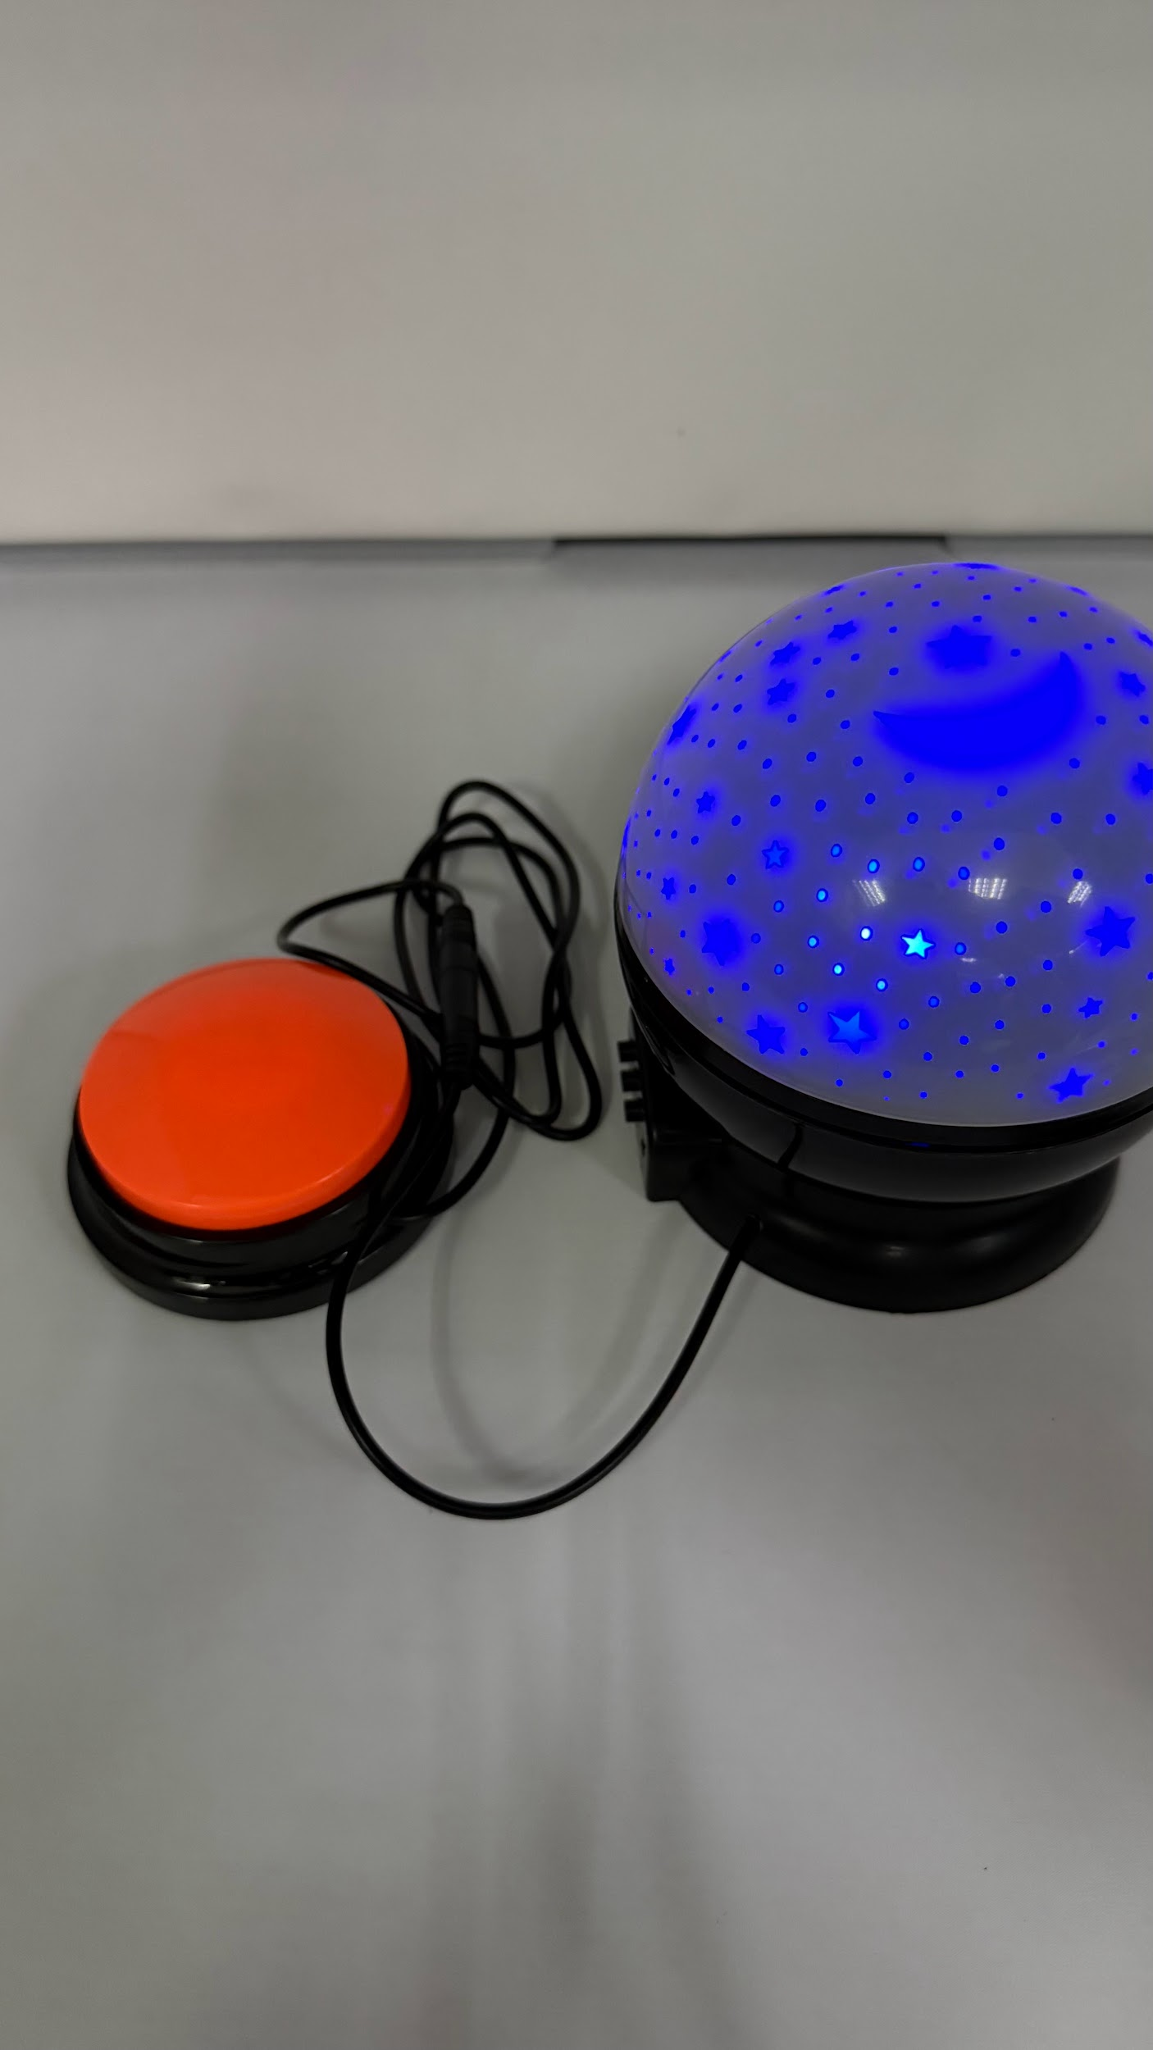

## 

## 2.1 Set Up Instructions

Use the following table for a step-by-step guide to setting up the product:

| **Setting up** | |
| --- | --- |
| Open the battery cover and install 2 AAA batteries. |  |
| Press and hold the bottom REC button to start recording audio. It can record up to 30seconds. |  |
| Press the top button to playback the audio. |  |
| Connect the 3.5mm male mono jack cable to an adapted toy with female mono jack to trigger power on/off. |  |

## 2.2 Maintenance

1. Remove AA batteries if the Adapted Recorder Button is not in use to prevent battery leak and corrosion.
2. If AA battery leaks, please change it
3. The device can be wiped clean with a damp cloth. Do not wash or submerge in water.

## 2.3 Troubleshooting

| **Problem** | **Possible Cause** | **What You Can Try** |
| --- | --- | --- |
| Adapted Recorder Button not working | Battery drain | Change the battery to see if it works |
| Battery spoilt because of leakage | Change the battery to see if it works |
| Button spoilt because battery leakage and cause the contact point corroded | Check how bad the corrosion is? 1. If is very bad that it leak to the PCB, please replace the button, 2. If not try to clean up and replace the battery |
| Adapted Recorder Button faulty because of the solder broken | Open with the assembly instruction and try to check on it or contact EG for support. |
| Adapted Recorder Button playback sound but toy is not triggering | Toy issues | 1. Plug switch into a known working toy. If the switch is able to activate the working toy, the issue may lie with the original toy.  2. Check the toy's product manual for troubleshooting. |

# 3. Maker Guide: Assembly Instructions

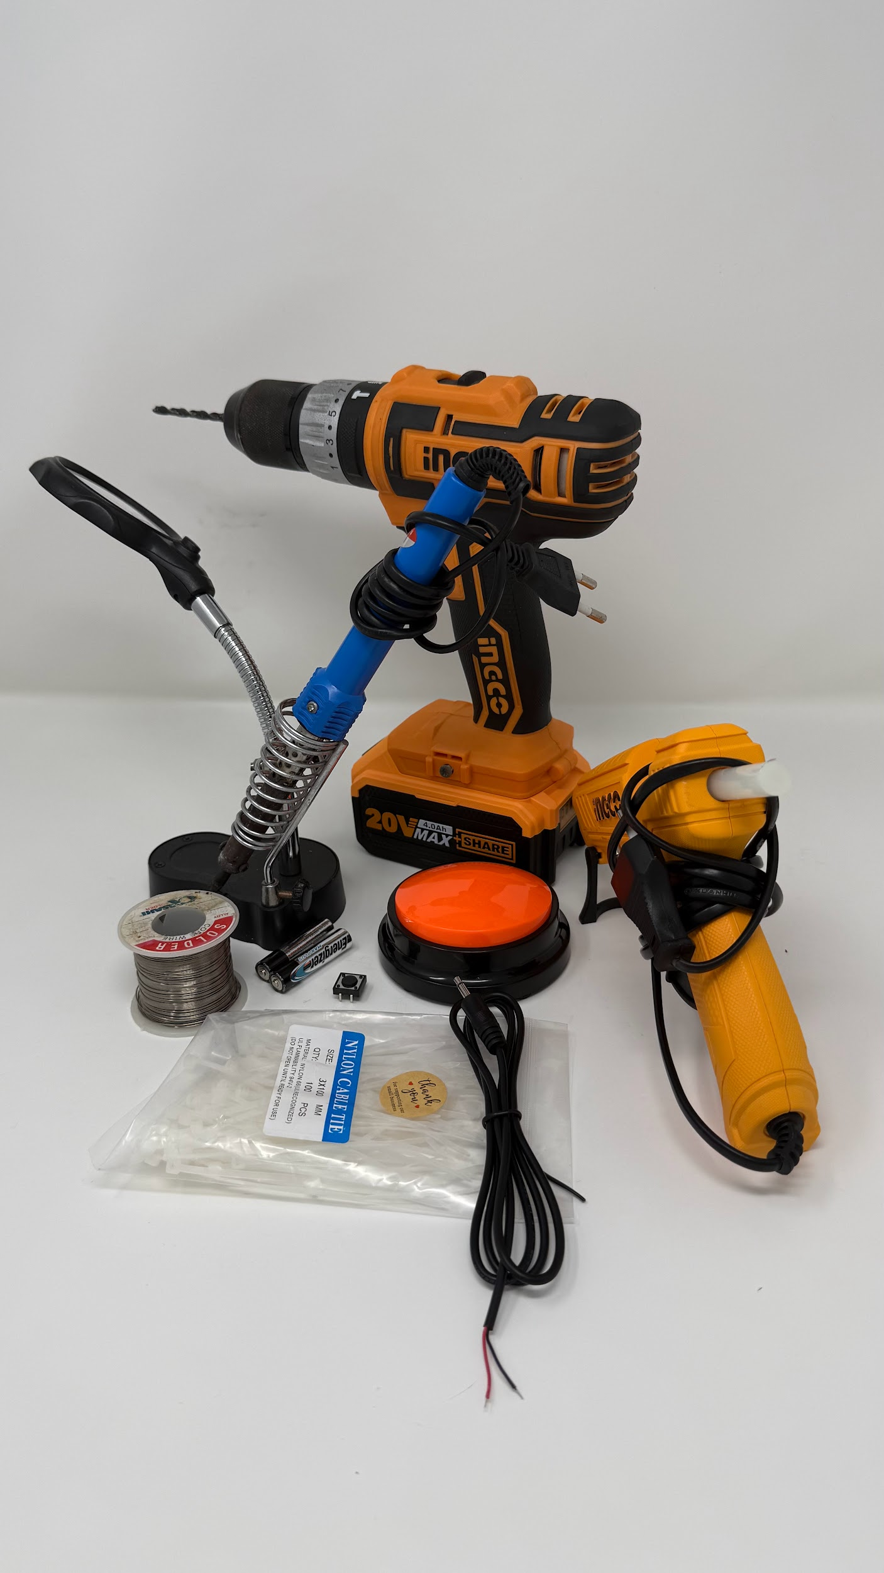

## 3.1 Assembly Guide

| Remove the black anti-slip rubber feet and unscrew the 4 screws. |  |
| --- | --- |
| Open up the button. Need push button and cable tie. |  |
| Drill a hole on the outer cover of the button. |  |
| Insert the 3.5mm male mono audio jack cable through the hole and secure it with a cable tie to prevent it from coming out. |  |
| Solder the extra push button and add a bit of hot glue to the existing push button.  *The amount of hot git should minimal so that the extra push button remind movable (rotatable) on the existing push button  Cut the form and the orange cover stand shorter to make space for the extra push button  *Do remember to keep the 3.5mm male mono audio jack cable inside the hole when you solder. |  |
| Install back the part and screw it |  |
| Test with a toy see if working |  |

# 4. Credit and Open Hardware Licence

This section provides the required legal notices and attribution for the open hardware design used to create this product.

## 4.1. Open Hardware Attribution

The core design for this Adapted Recorder Button is based on the Playback Switch, an open-source assistive technology project.

* Original Designer: Makers Making Change (a program of Neil Squire).
* Original Copyright: Copyright (c) Neil Squire / Makers Making Change.
* Original Source Location: The original project source files are available online at: <https://www.makersmakingchange.com/product/playback-switch/01tJR000003S43lYAC>

## 4.2. License Statement and Source Availability

The hardware design used in this product is licensed under the CERN Open Hardware Licence Version 2 – Weakly Reciprocal (CERN-OHL-W 2.0) or later.

By distributing this product, we are obligated to make the complete design source available to you.

* Complete Source Availability: The complete design files (Source), including schematics, assembly instructions, and any modifications made by Engineering Good, are available free of charge at a permanent online location: <https://github.com/Engineering-Good/T4G-Adapted-Recorder-Button>
* Modification Notice:This version of the Playback Switch design was modified by Engineering Good to include the 3.5mm mono audio jack functionality for triggering other toys. The full, modified source is available at the URL listed above.
* Full License Text: The complete legal text of the CERN Open Hardware Licence Version 2 – Weakly Reciprocal** follows this section.

## 4.3 CERN Open Hardware Licence Version 2 – Weakly Reciprocal (CERN-OHL-W 2.0)

The full text of the license is available here: [CERN-OHL-W 2.0 Full Text](https://gitlab.com/ohwr/project/cernohl/-/wikis/uploads/82b567f43ce515395f7ddbfbad7a8806/cern_ohl_w_v2.txt)

### 